RC Solar Water Body Cleaner Drone

Although water is an irreplaceable resource for the survival of human species, the contamination of water bodies resulting from daily human activities has led to a depletion in the available sources of potable water.
Although, finding more reliable and sustainable methods of waste water treatment and garbage disposal is instrumental in combating water pollution in the long run, cleaning up water bodies is a far more pressing issue.
The major issues with cleaning Lakes and Pools are
- Finding/hiring motorized boats each time for cleaning
- 2 People team – 1 for driving other for collecting trash
- Not being able to clean regularly due to manual process
- Higher salary and motor boat costs involved of cleaning
Using two powerful electric motors for propulsion, this RC Lake cleaner Drone has been designed to skim and clean the surface of open water bodies such as lakes, ponds, rivers, canals etc.
This system consists of a wire mesh that collects garbage floating on the surface of water bodies as it sails through. Along with helping clean up water bodies, this boat is equipped with Ph and Turbidity sensors that help to map and detect the level of pollution in a water body.
This boat is completely rudderless and steers itself by varying the thrust on either of its motors. Thereby, improving reliability by reducing the number of moving parts.
The six solar panels mounted on its top help to increase the life of its battery and enable it to run for longer hours.
Then RC Solar Lake Pool Cleaner offers following benefits
- Remote control operation makes it a single person job.
- Skims the surface of water bodies and uses a wire mesh to collect garbage.
- Ph and Turbidity sensor help in detecting the level of pollution.
- Solar Panels helps to increase the battery life and increase operational hours.
- Rudderless operation ensures simplicity and makes the system easy to repair.
- Wireless Live Stream Camera For Android Display.
- 24v strobe light improves visibility in fog and low-light conditions.
The RC cleaner drone utilizes 2x High torque motors, RC Controller, Solar Panels, 2x Sensors, wireless camera, collector mesh and an Atmega microcontroller to achieve this task. The dual drive rudderless motor system is used to provide drive to the rc boat using dual propulsion system. This allows for an easy rudderless movement control.
The collector mesh is enclosed inside the rc boat frame to capture surface garbage floating on water. This allows the drone to swallow all the garbage coming in its path and take it ahead. Any sea creatures caught along with the garbage may easily swim out of the mesh through front opening if caught, thus it dosent harm any sea life.
The RC controller is used to send movement controls to the drone controller unit via RF signals. These signals are received and decoded by the controller unit and then processed by microcontroller to operate drive motors. The drone uses 2x sensors (Ph and turbidiy) to sense and ph and turbidity level of water pollution which are constantly stored in the memory card for later reference.
The top mounted solar panels are used to draw solar power and constantly charge the battery as the drone operates. Even if the drone shuts down in the middle of the lake. Half an hour of sunlight can again make the robot operational again. Also a top mounted strobe light is used to find the drone in darkness or misty conditions. This allows for a remotely operated long range lake pool cleaner drone.

Components:
- Atmega Microcontroller
- 2 x High Torque Motors
- 2 x Propellers
- Solar Panels
- Ph Sensor
- Turbidity Sensor
- Wireless Camera
- RC transmitter
- RC Receiver Circuit
- Motor Drivers
- Strobe Light
- PCB Board
- Electronics Components
- Drone Frame
- Supporting Frame
- Mounts and Jounts
- Screws and Bolts

Applications:
- Helpful in monitoring water pollution and cleaning water bodies.

Advantages:
- Remote control operation makes it a single person job.
- Skims the surface of water bodies and uses a wire mesh to collect garbage.
- Ph and Turbidity sensor help in detecting the level of pollution.
- Solar Panels helps to increase the battery life and increase operational hours.
- Rudderless operation ensures simplicity and makes the system easy to repair.
- Wireless Live Stream Camera For Android Display.
- 24v strobe light improves visibility in fog and low-light conditions.

Block Diagram:

Front View
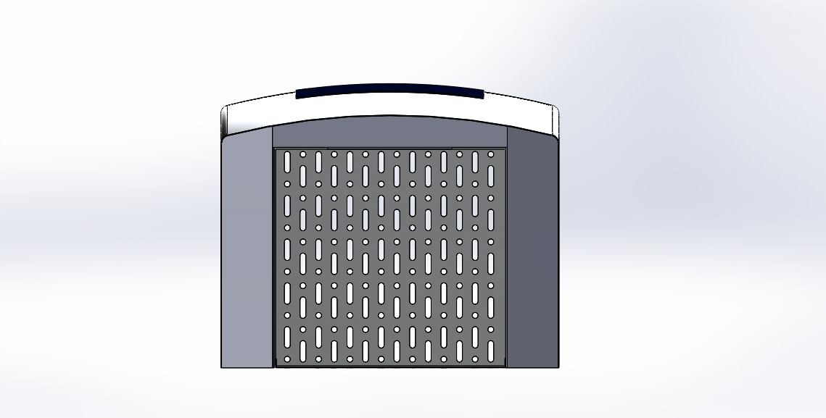

3D View
